Western Valley
by
Connie Tindale
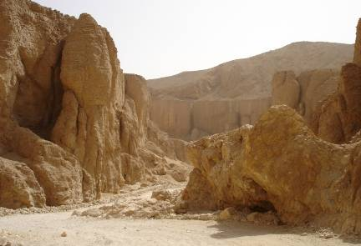

Location: A long spur that runs off the main Valley of the Kings on the West Bank of the Nile.
Attraction: Magnificent rock formations and the tomb of King Ay
.Cost: 20 LE entrance fee for the tomb of King Ay. Tickets at the entrance to the Valley of the Kings,
Opening times: 7.00 am until 4.00 p.m. in winter
7.00 am until 5.00 p.m. in summer.

The Western Valley is a 3 kilometre spur that runs off the Valley of the Kings and is a quiet ethereal place that wends its way inside the mountain. The road as far as King

The Western Valley, which is also known as the Valley of the Baboons after the caches of mummified baboons that were found there, is a desolate but stunningly beautiful canyon off the Valley of the Kings. The Valley is the home of Meretseger, a local goddess whose name means "She who loves Silence". Despite the crowds flocking into the nearby Valley of the Kings, the silence in this lonely place is palpable.

There are four known tombs here but three of them are closed. The closed tombs include the unused tomb of King Akhenaten (WV 25), the tomb of Amenhotep (Amenophis) III (WV 22) and a large a tomb which appears to have been used mainly as a storage area for other tombs. King Akhenaten's tomb is large and well finished but despite this, he was buried in Amarna the place he chose to be his new capital. The entrance to his tomb was recently used as a substitute for King Tutankhamun's tomb in the BBC's 2005 production of the explorations of Carter, Champollion and Belzoni.

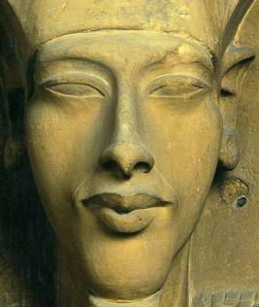
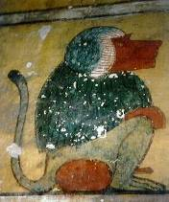
Above: Images of baboons decorate Ay’s tomb.
Left: Akhenaten who never used his Valley tomb.

The open tomb is that of King Ay (WV 23), which was discovered by Belzoni in 1816 but was opened to the public only in the 1990's. Ay's reign lasted only four years (1339-1335 BC) and he was not of royal blood but became king only by default after the death of the young King Tutankhamun who he has often been accused of murdering. Recent studies indicate that that Tutankhamun did not meet a violent death but the notion that he died of natural causes is not as intriguing as having him part of a plot, so Ay is still likely to continue to be unjustly accused.

This tomb could have originally been intended for Tutankhamun so that he could be buried near his grandfather Amenophis III but his early death meant that he was buried in Valley of the Kings instead.

The tomb is small compared with many of those in the neighbouring valley and is noted only for its baboon paintings and its marsh scenes. The marsh scenes are unique in royal tombs as they are usually seen only in the tombs of commoners, which in fact King Ay originally was. There are twelve stylised ducks in this scene that could represent the hours of the day and night, but this is only conjecture. The walls also have copies of pages from the Book of the Dead to ensure that the King can find his way through the Underworld and into eternal life.

In the centre of the burial chamber is a well decorated sarcophagus, which had been badly damaged and was removed from the tomb for restoration in the latter part of the nineteenth century and was only replaced a century later.
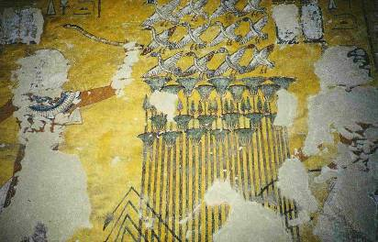

Images of King Ay have been defaced but the marsh scenes are still clear.

All the images of Ay suffered vandalism in ancient times by someone who knew where his tomb was. Perhaps this was done by King Horemheb his successor or by the Priests of Amun as a backlash of animosity towards King Akhenaten for whom Ay had acted as a minister. Akhenaten, was Tutankhamun’s father and he introduced a new monotheistic religion into Egypt which had would have justifiably angered Amun's Priests. When Amun was restored as the principal god, Akhenaten was reviled and many monuments to him and his supporters were vandalised.

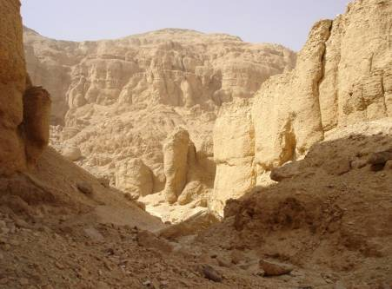
The canyon beyond King Ay’s tomb.

The paintings and mummies of the baboons in Ay’s tomb may have venerated the Sun Temple of Thoth, a god to whom baboons were sacred. This remote temple, which lies on a spur 400m above the Valley, has no public access and can only be reached on foot or by donkey via a steep 5 km long path starting near Howard Carter’s house.

The road to Ay’s tomb is wide enough for motor vehicle access and visitors who are in a hurry might prefer to visit the Valley by taxi, or private car. However, the best way to see this Valley is on foot then you can admire its rock formations and investigate the narrow paths that lead through them. The path leading into the canyon beyond Ay’s’ tomb is magical and as it gets narrower and narrower it hints of a more mystical world.

If you decide to walk the length of the Valley and back, then allow about two hours. The guard with the key to the tomb, and to the generator that lights it, is inside a small house a short way into the Valley.

The best time to visit the Valley is early morning before the heat of the day becomes too intense or late in the afternoon after the heat has passed, but be sure to allow enough time to see the Valley before closing time. Remember to take extra water with you because it can get very hot there and you might become dehydrated without it.

NB: Amenophis III (also known as Amenhotep III) was a prolific builder and was responsible for construction of the main part of Luxor Temple as well as his pleasure palace (Malqata) and his massive mortuary temple on the West Bank of which only the Colossi of Memnon now remain.

