Ramesseum
(Mortuary Temple of Ramses II)
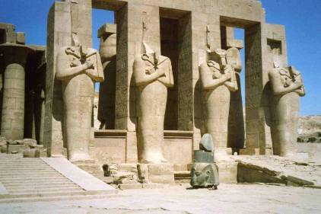
by Connie Tindale

Location: On the right hand side of the road, several hundred metres north of the West Bank Ticket Office.
Attractions: The huge broken statue of Ramses II, well preserved mud brick wine vaults and impressive wall carvings.
Cost: 20 LE – tickets must be bought at the Ticket Office.
Opening Times: 7.00 am until 5.00 p.m. in winter
7.00 am until 6.00 p.m. in summer.

Ramses II followed his father Seti I as Pharaoh of all Egypt and ruled from 1279-1213 BC (19th Dynasty). He is perhaps the most well known of Egypt’s Pharaohs and reigned for 67 years. In Thebes, his greatest building achievements were extensions to Karnak and Luxor Temples and completion of the tomb of his favourite wife Nefertari in the Valley of the Queens, but the one that would have been most important to him would be his own mortuary temple which he intended to last for a million years. Unfortunately, the place he chose to build it was prone to flooding and occasional earthquakes, which eventually caused its ruin.

The Ramesseum is most famous for its huge statues some of which might have been usurped from the mortuary temple of Amenophis III as many of the Ramesseums’s building blocks are known to have come from that site. In the forecourt of The Ramesseum are several impressive statues of Ramses in the form of Osiris but the most atmospheric statue is massive and carved in rose granite. It once stood almost 18 metres high and now lies face down on the ground, broken and forlorn. It was this statue that prompted the poet Percy Bysshe Shelley to write ‘Ozymandias’.

The original entrance to the temple faced the river but this entrance is now largely inaccessible and visitors enter from the side. Beyond the crumbling forecourts and the statues of Ramses as Osiris, the temple is remarkably intact with 29 of the original 48 columns in the hypostyle hall still standing. There are some fine carvings of Ramses’ achievements and of him making offerings to the various Gods to ensure his passage through the underworld into eternal life.

Ramses tomb in the Valley of the Kings (KV7) was also badly situated and suffered severe damaged from continual flooding. His mummy was moved to safety several times in antiquity and was eventually found in the royal cache to the south of the Deir el Bahri but it was well preserved and is now in Cairo Museum.
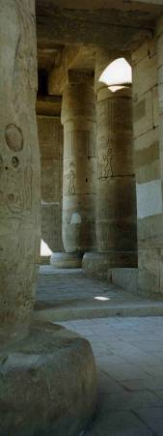
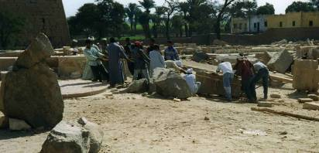
Above: Workers manually haul a massive stone into place using ropes., just as workers from the Deir el Medina would have done in antiquity.

Left: Despite earthquake damage, 29 out of the original 48 columns in the hypostyle hall are still standing.

Below: The massive rose granite statue of Ramses II lies face down in the sand and prompted Shelley to write the poem Ozymandias..
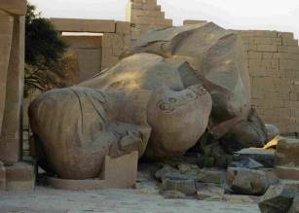
….
My name is Ozymandias, king of kings,
Look on my works, ye Mighty and despair”.
Nothing beside remains. Round the decay,
Of that colossal wreck, boundless and bare,
The lone and level sands stretch far away.

Percy Bysshe Shelley
(1792 –1822)

