Colossus of Memnon
(Mortuary Temple of Amenophis III)
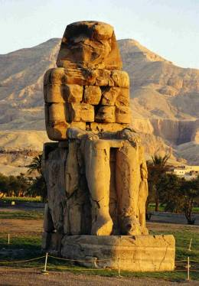
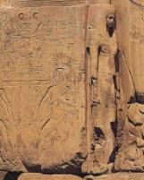
by Connie Tindale
Left: The colossal statue of Amenophis III is one of a pair known as the Colossi of Memnon
Above: Amenophis’s wife and mother stand eternally at his feet.

Location: About 2 kilometres from the ferry on the stretch of road from the checkpoint to the ticket office on the West Bank.
Attraction: Two giant statues that once fronted the mortuary temple of Amenophis III.
Cost: No charge
Opening Hours: 24 hours.

Two giant quartzite statues known as the Colossi of Memnon are all that remain of the magnificent structure which was built as a mortuary temple for Amenophis III. Originally the statues flanked the pylon gates of the temple, now they sit side by side amid fields of corn with their hands placed neatly upon their knees, quietly facing east waiting for the rise of the new-born sun. On one side of Amenophis’s feet stands the diminutive figure of his wife Queen Tiye and on the other side stands an equally diminutive figure of his mother Queen Mutemuia.

These two colossal statues were misnamed Memnon by the Greeks who thought that they represented the mighty Memnon who Achilles killed in the battle for Troy. In Roman times, wind passing through a crack in the northern statue gave out a baleful cry which was thought to be Memnon crying to his mother Eos. The crack appeared after an earthquake around 30 BC and stopped when Septimus Severus ordered its repair in 199 AD. The statues although faceless and badly damaged are still very impressive although the southern statue now has an appearance of being burned after it was recently treated with preserving material. |

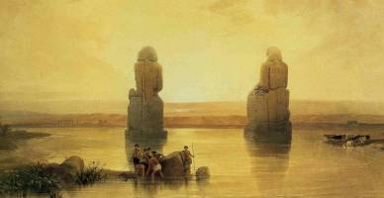

This early painting by David Roberts in 1838 shows how the site flooded regularly

Amenophis III, now also referred to as Amenhotep III, came to the throne when he was only 12 years old and ruled Egypt from 1390 – 1352 BC when he died at the age of 49 years. He was buried in the Western Valley near the Valley of the Kings.

His reign was a time of peace and prosperity when Egypt’s wealth increased enormously and, without any wars to worry about, he embarked on a large building programme including a mud-brick palace known as Malqata, the scant ruins of which are close to the Medinet Habu. In size, his mortuary temple may well have rivalled that of the mighty temple at Karnak but it was built on the flood-plane and suffered erosion and earthquake damage soon after its completion. Many of its finely carved stone blocks were later reused in the building of the Medinet Habu and the Ramesseum. Extensive excavation of the temple site has recently started and the bases of some exceptionally large statues have been uncovered.. (2005).

The car park beside the statues can be full of tour buses early in the morning so the best time to view the statues is late in the afternoon when most of the tour buses have left or at night when the statues are floodlit.

