Temple of Seti I
by
Stan Kurowski
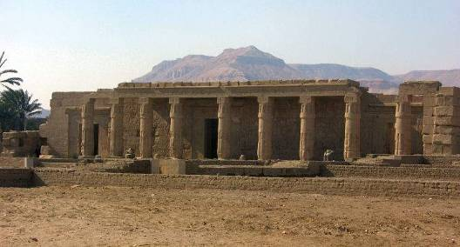
The front of this temple aligns with the hypostyle hall at Karnak

Location: You pass the Ramesseum, heading for the Valley of the Kings and turn right, instead of left at the junction. The temple is about 500m on the right.

Attraction: A quiet, rarely visited temple with fine workmanship.

Cost: 20 LE. Ticket must be bought from the Main Ticket Office

Opening Hours: 7.00 a.m. – 5.00 p.m. in winter
7.00 a.m. – 6. 00pm in summer

Seti I was the son of the pharaoh Ramses I (19th Dynasty), a general who became third in a line of non-royal Pharaohs. Ramses only ruled for about 2 years, and had no time to plan and build a mortuary temple of his own but his son Seti was an enthusiastic builder and completed temples in both Upper and Lower Egypt, including the magnificent temple to Osiris at Abydos.

Seti was one of the great warrior pharaohs of Egypt, and spent much of his reign repairing the damage, that the neglect of foreign affairs in the Amarna period under Akhenaten had done to Egypt’s empire. Once he had subdued the rebellious tribes – he recovered territory from the Syrians, Hittites and Libyans - he concentrated on building his temples and his tomb and on restoring the temples of gods that had previously fallen from favour.

This Temple of the Million Years, being siutated in Adb el Gurna, is the most northerly of the West Bank temples. It is called Qasr el-Rubaiq by the locals but in pharaonic times was originally known as "Seti I is Beneficent in the Domain of Amun, which is on the West of Thebes". The temple, which is aligned to the East, was intended to be a companion to the hypostyle hall which Seti had enlarged at Karnak and is built to face it. It is believed that it became the seat of government for the West Bank during and after Seti’s reign.

The craftsmanship used by the builders of Seti’s tomb and temples is at the highest peak of Egyptian work. Unfortunately, he died before this temple was completed and it was finished by his son Ramses II. The difference in craftsmanship between father and son can easily be seen. Ramses was above all else concerned with the quantity of his monuments – even taking other monuments as his own - and quality did not seem to be so important to him.

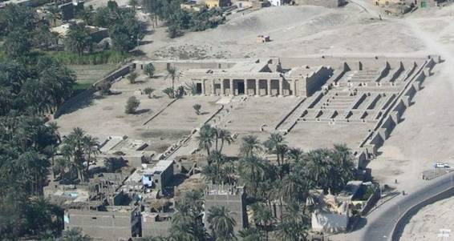
Originally, the temple was built with two sets of pylons enclosing two courtyards, leading to the façade of the temple proper. The first pylon has almost completely disappeared into the surrounding village, and the second has just the barest outline as they were made of mud brick. The whole complex, including a small symbolic palace for the soul of the dead king, a sacred lake and storehouses was surrounded by a mud brick wall. Much of the damage to the temple was done during the Christian period, when a church was built in the northern part of the site, and houses were built within its precincts.

This aerial view of the temple clearly shows its layout and its chapels

The approach to the main portico of the temple was originally lined with sphinxes, similar to those at Karnak and Luxor. The portico consists of 9 papyrus headed columns, and the scenes shown on its walls and columns depict Ramses II, instead of Seti, celebrating the Beautiful Festival of the Valley.

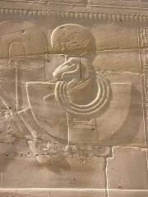
On coming through the main entrance, visitors enter a small hypostyle hall containing 6 papyrus headed columns. Three chapels are to be seen on both the north and south walls of the hall. This is the most complete part of the temple. The decoration inside shows Seti worshipping the gods, but the decoration on the walls and columns show Ramses with his deified father as these were finished after Seti’s death.
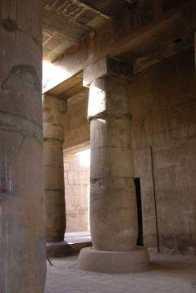
Above: The quality of work in this temple is of the highest standard.

Left: The Hypostyle Hall

Around the hypostyle hall and its chapels are several other chapels – to the west there are 4 chapels dedicated to the king’s funerary cult, and to the north, there is a sun chapel, with excellent carvings.

On leaving the temple, visitors can climb the restored mud-brick wall and walk back to the entrance along its ramparts. An excellent view of the temple as a whole can be obtained from this wall – ideal for photographs. Unlike the other temples, Seti’s temple is never crowded and can be visited at any time during the day.

