Medinet Habu
(Mortuary Temple of Ramses III)
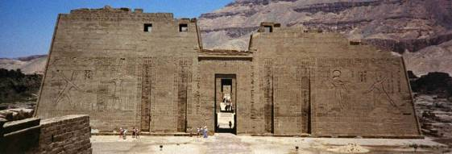
by Connie Tindale

Location: Off a side-road to the left just beyond the Colossi of Memnon
Attraction: A well preserved temple with deeply carved reliefs and good remaining colour, second in size only to Karnak.
Cost: 20 LE. Ticket from Central Ticket Office
Opening hours: 7.00 a.m. – 5.00 p.m. winter time
7.00 a.m. – 6.00 p.m. summer time.

Ramses III reigned Egypt for 31 years (1184 –1153 BC) and like many pharaohs before him was a prodigious builder. As well as greatly enlarging the Medinet Habu (Habu’s City) to become his mortuary palace, he built the wonderful Osiris courtyard in Karnak temple.

The Medinet Habu was a sacred site long before Ramses III started building there. It was a revered part of the creation myth and was believed to be where the Ogdoad (eight primeval gods) placed the egg from which the sun came, but Ramses’ works made it the most beautiful of the Theban sites. The temple, which is of a similar design to the Ramesseum, is second in size only to Karnak but has a grace and symmetry that Karnak lacks. It was not just a mortuary temple as it incorporated Ramses’ palace where he lodged on his visits to Thebes, his pleasure rooms where he entertained his harem, his government offices, a sacred lake and a Nilometer which measured the rise and fall of the river. The outer walls of the temple are also finely decorated and a mud-brick wall surrounds the whole complex.

Ramses III was the son and heir of Sethnakht who became the first King of the 20th Dynasty. Sethnatkht’s path to the throne is unclear. It is possible that there was a family relationship between him and Ramses II, but it is just as likely that he grabbed power when the opportunity arose just as Ay and Horemheb had before him. Ramses made his own claim to the throne clear by having the words “I did not take my office by robbery, but the crown was set upon my head willingly” inscribed on one of the temple pylons.

During his long reign, Ramses III fought several campaigns including the battle with the sea peoples, which is shown on the walls of inner walls of the first pylon. However, even in peaceful times there was wide spread corruption and internal strife in Egypt. This unrest might have led to the harem plot, which occurred later in his reign, when several of his ministers and his wife Ty aimed to have him assassinated during the Opet festival celebrations, intending to make Ty’s son king. Despite the wide use of magic and spells, the plot appears to have failed as the culprits were caught and forced to commit suicide, but as Ramses appears to have died before their trial was complete, who is to say that they did not succeed in killing him after all. He was buried in the Valley of the Kings (KV 11) in an elaborate tomb that was initially intended for his father.
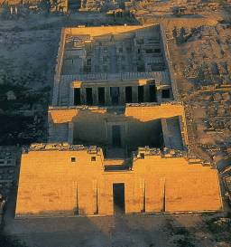
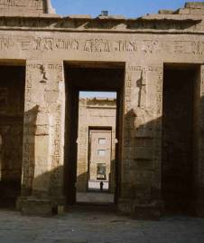
Above left: this Aerial view of the temple clearly shows its layout but disguises its size
Above right: Looking through the temple towards the windowed gateway where Ramses had his pleasure rooms – the small figure gives an idea of the scale of the temple

Before entering the mortuary temple visitors pass under the windowed gateway where Ramses had his pleasure rooms and enter an open space which was once a magnificent garden. Facing, is the deeply carved first pylon, which shows Ramses fighting imaginary battles against the enemies of Egypt but on the inner walls are scenes of battles that he really did fight and win. To the right of the gateway is the temple that Hatshepsut built and on the left is the temple of the Divine Adoratrix, which was added at a later date.

Inside the first pylon is a large open courtyard, and on the northern side stands rather fat-legged statues of Ramses in the form of Osiris with wives at his feet. Unfortunately, many of these statues were removed to make way for a Coptic Church, which remained inside the temple until the nineteenth century.

In the second courtyard, a series of reliefs show scribes completing a tally of the dead after a battle with the Libyans. This series is interesting as it starts with the counting of hands, which confused the issue as each enemy had two, and finishes by counting penises of which they only had one.

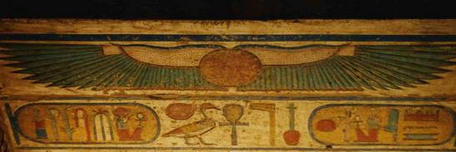
At the rear of this second courtyard is an enclosed columned area where the decoration is entirely religious and very colourful. The ceilings here are finely painted and the show many illustrations of Ramses offering gifts to the gods. Ramses, who had learned from experience that the names of out-of-favour gods and Pharaohs were easily obliterated, made sure that names carved in his temple were exceptionally deep. Some were defaced but most were plastered over with mud during the Coptic era rather than being destroyed.

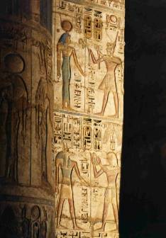
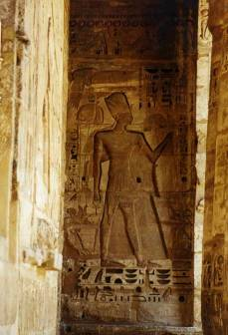

Top: This spectacular winged sun disc is on the ceiling of the enclosed area at the rear of the second courtyard.

Bottom: The reliefs on the walls and columns of the temple are deeply cut and still retain good colour.

Beyond the second courtyard is the hypostyle hall, which is now roofless and largely ruined but has some very interesting sanctuaries and chapels leading from it. To the left are chapels to Ramses and Osiris and on the right are chapels and storerooms decorated with scenes from the Opet festival and the annual festival for the fertility god Amun-Min. At the back are three sanctuaries to the Theban triad of Amun, Mut and Khonsu.

The temple has a chequered history. Apart from being plastered over with mud and turned into a Coptic monastery, when the Egyptian economy began to crumble it was the scene of a labour demonstration. Workers from Deir el Medina gathered there when they went on strike over their lack of pay and poor conditions of employment. Was this the first organised labour dispute? When social order broke down even further, gangs of Libyan bandits roamed the area and when they were attacked, the entire population of Deir el Medina abandoned their town and took refuge within the temple walls.

The temple is interesting enough to be visited several times and on each visit something new will be discovered. The outer walls are worth walking around to view the decoration and to see the ruins of Ramses’ palace. There is a calendar of festivals and scenes of Ramses hunting and fighting various battles.

Although it tends to be less crowded than some of the other archaeological sites, it can still get very busy in the mornings when the tour buses arrive but they tend to have whistle stop tours and the site quickly becomes peaceful again.

