Luxor Temple
By Connie Tindale

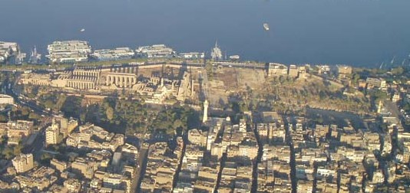

Luxor Temple from the air – photo by BBLUX

Location: On the Corniche el Nil, in central Luxor
Attraction: Graceful temple with gigantic columns, statues of Ramses II, an obelisk and an avenue of Sphinxes.

Cost: 35 LE tickets from the site.
Opening Hours: 6.00 a.m. until 9.00 p.m. in winter
6.00 a.m. until 10.00 p.m. in summer

The first glimpse many visitors have of this temple is from the river when their cruise liner docks alongside the Corniche el Nil. From there, it is easy to visualise the sacred barques that long ago brought the god Amun-Min and his wife Mut down the river from Karnak for their annual honeymoon during the Opet Festival. The temple is clearly visible from the Corniche and at night makes a spectacular sight as its courtyards and statues are floodlit until the temple closes.

If you look carefully at the aerial photograph shown above, you can see that the layout of the temple is not symmetrical and that its axis is slightly skewed. Amenophis III, (Amenhotep - 18th dynasty) who also built a massive mortuary temple on the West Bank and the so-called Colossi of Memnon, built the larger straighter part of the temple and Ramses II (19th dynasty) built the skewed additions. They were probably made at an angle to incorporate some earlier sanctuaries and to align with the avenue that once joined Luxor Temple to Karnak Temple. The avenue was three kilometres long and during the 30th Dynasty was lined with sphinxes on the orders of Nectanebo. Most of the Avenue has been lost under the buildings of modern Luxor, although an impressive line of them remains in the temple grounds.

The original temple was small and honoured the annual Opet Festival which was held in the second month of summer when the Nile was in flood. This early structure had shrines built by Hatshepsut which were later augmented by her brother Tutmosis III, but there are signs of a temple being there from the Middle Kingdom era. The older parts of the temple were mainly dismantled and re-used when construction of the larger temple began and there is now little visual evidence of them. During Amenophis's reign, the temple became known as the “Harem of the South” and it gained the magnificence that we see today. A detailed floor plan of the temple is shown at the end of this article.

Although Amun Min was later brought to Luxor by river, originally he was carried along the Avenue and a carnival atmosphere would have prevailed. The temple’s massive columns would have been brightly coloured and, during the Opet festival, its courtyards would be filled with music and dancing as priests, performed the rituals necessary to bring prosperity to Upper Egypt. In ancient times, ordinary people would not have been allowed inside the temple precincts and only a carefully selected audience would witness these. This ancient festival is now mirrored in the Abu el Haggag Moulid that takes places annually in the month of Charban, just before the start of Ramadan. Abu el Haggag was a local Islamic holy man who, during the middle ages, was buried in a debris-filled shrine inside the temple. A description of this Moulid can be found in the Religious Festivals section of the Guide to Luxor.

When the power of the priests dwindled and Thebes reverted to being a backwater, villagers made their homes inside the temple walls and brought their new religions with them. Now, when you pass through the entrance, you not only see a colonnaded courtyard which is lined with statues of Ramses II but also a mosque which the villagers refused to destroy when they were moved out of the temple in the nineteenth century. The mosque honours Abu el Haggag and as it is still in use, it means there has been 4,000 years of worship on this site. It was rebuilt in the nineteenth century but it still has its original 11th century minaret.

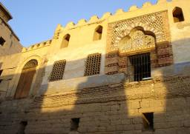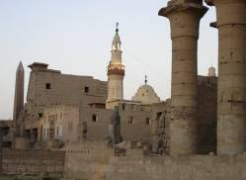

The Abu el Haggag Mosque is still in use and marks 4,000 years of worship on the site.

In front of the temple’s first pylon, which is decorated with scenes of Ramses victory at the battle of Kadesh, is an obelisk that has four dog-headed baboons at its base. In keeping with the temple’s fertility connections, the baboons originally had erect penises but despite surviving intact for thousands of years, they were unfortunately destroyed by over-prudish Victorian archaeologists. The Obelisk was once one a pair but its counterpart now stands in the Place de la Concorde in Paris as it was given to Louis Phillippe as a gift.

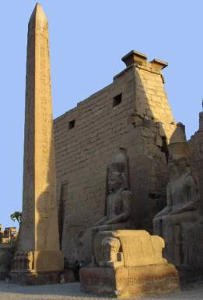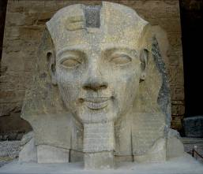
Left: The obelisk and first pylon fronted by seated statues of Ramses II
Belowe: An impressive stone head of Ramses II is mounted on a plinth.

Originally there were six statues of Ramses II at the front on the temple – four standing and two seated - but now only the two seated and one badly damaged
standing statue remain. The seated statues sit either side of the entrance and stare towards Karnak. To the left of the obelisk, mounted on a plinth, is an impressive stone head of Ramses II.

The first courtyard is surrounded by a double row of papyrus bud columns that once supported a roof, which would have provided the temple with darkness and a secretive air. Between many of the columns are fine statues of Ramses standing with one foot forward, giving him stability and grace. Reliefs, which were added later, show his funeral procession where he is attended by many of his numerous sons. Also, there is an unusual relief of the temple itself showing its obelisks and banners. This part of the temple is linked to the older part through the second pylon, which is flanked by colossal statues of Ramses seated. Beyond this pylon, is a magnificent Colonnade of pillars, which was started by Amenophis III and added to by his grandson Tutankhamun and his successors, Ay and Horemheb.

At 21 metres high (68 feet), even today the Colonnade is impressive; when it was erected it would have been completely awe-inspiring. The Colonnade has fourteen columns, all, with open papyrus capitals, that would have supported a roof. This, together with the decorated walls, would have created an enclosed dark tunnel leading from darkness into light, which could have invoked religious ecstasies. Only the base of the surrounding walls has survived but it gives a detailed account of the progression of the Opet festival, the purpose of which was to rejuvenate the King's powers as well as to honour the Gods.
Above: Graceful statues of Ramses II line the first courtyard.

Right: The Colonnade is 21 metres and was a dark tunnel leading into an open courtyard.

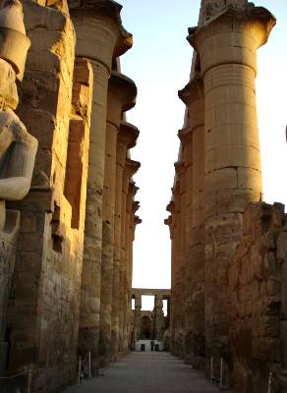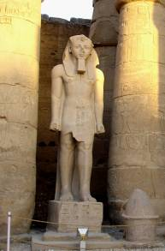
Right: The Colonnade is 21 metres high and was a dark tunnel leading into an open courtyard. Below: Graceful statues of Ramses II line the first courtyard

Beyond the Colonnade is a large open-aired courtyard, which may have been dedicated by Amenophis III to the sun disc Aten. This courtyard is innovative as it moves away from the usual secretive ambience, towards a celebration of light.

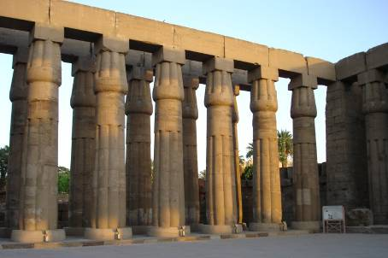

The unroofed solar courtyard leads from the darkness of the colonnade to a celebration of light

The Solar Courtyard is unpaved and in 1989, workmen accidentally discovered a cache of statues that had remained hidden for nearly two thousand years. The statues had been buried during the Roman occupation when new Emperors had greater importance than old Pharaohs and somewhere had to be found to store surplus statuary. Burying the statues preserved them and they now represent some of the finest examples of Egyptian craftsmanship. Many of these statues are on display in Luxor Museum.

At the rear of the solar courtyard is a hypostyle hall that has thirty-six remaining columns, some of which are badly damaged. Beyond that is a warren of some fifty chambers and sanctuaries that have been usurped, enlarged, embellished and in some cases plastered over as various monarchs left their mark. At one time, it was thought that part of this area might have been used as a Christian Chapel, but this is now considered unlikely.

This part of the temple is actually its heart, the place where the barques of Amun, Mut and their son Khonsu were kept during their brief stay. Here also lies the birthing room, which proves the Pharaoh's divine is link with the gods. Either Amenophis or Alexander is shown here being formed by the gods on a potter's wheel. The sacred barque of Amun was housed in the Third Antechamber and four pillars marked the place where the barque was placed. These pillars were replaced with a chamber during the reign of Alexander the Great and the change in building style is quite evident.

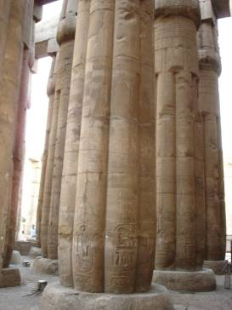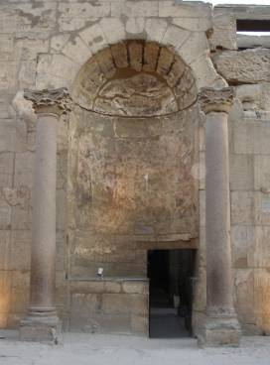

Above left: At the rear of the Solar court is a hypostyle hall with 36 remaining columns
Above right: The doorway to the Third Antechamber, which housed the barque of Amun.

All around the temple are ruins of priests'' quarters and a garrison. Piles of carved blocks salvaged from fallen walls lie waiting for reconstruction; which is a task that might be completed on a computer screen if not in real life. However, with the new excavations that are taking place, their original positions might still be located.

In November 2005, work started to clear the way for making Luxor Temple part of the biggest open-air Museum in the world. Millions of pounds became available to preserve the Temple from the rising water level, which was destroying the structure, and causing stonework to crack and decay. In addition to this, modern buildings directly around the Temple have been scheduled for demolition so that archaeologists can uncover the foundations of more of the temple. A road is also planned to once again join Luxor and Karnak Temples.

The best time to see this temple is at dusk when the fading light gives an impression of how the temple would have looked when it had its roof. The temple is floodlit and as the glow of the lights increases the true beauty of this temple becomes more evident.
Luxor Temple
