Deir el Medina
(Workers' Village)
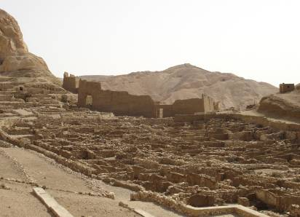
by Connie Tindale

The layout of the Deir el Medina village is clearly visible.

Location: Nestled in a valley on the southern edge of the Theban Hills. Off the road to the Valley of the Queens
Attraction: Temple to Hathor, tombs of artisans and the ruins of the Workers' Village.
Cost: 20 LE– Temple, ruins, and two tombs. 10 LE - for ticket to tomb of Pashedu. Tickets from Main Ticket Office.
Opening Hours: 7.00 a.m. – 5.00 p.m. in winter
7.00 a.m. – 6.00 p.m. in summer

Deir el Medina is the Arabic term for Monastery of the City. In this instance 'Monastery' refers to the Coptic monastery that was built there much later and 'City' refers to the Medinet Habu, but originally the village was known simply as Pa-demi- 'the town'.

During the 18th – 20th New Kingdom Dynasties, this village was a hive of activity. Not only did guards protect it, but also entry to it was most likely restricted to those who lived there. Intruders were likely to be killed. The residents of its seventy houses were gifted artisans who had the favour of the Pharaohs for whom they prepared tombs in the Valley of the Kings- ‘Houses of Eternity’. It was the workers’ task to dig, prepare, and decorate the tombs; and that made them holders of secrets. Not only did they know where the Pharaohs’ tombs were they also knew precisely what was in them and that made the tombs vulnerable to robbers; consequently, the village was deliberately isolated.

However, as most tombs were actually robbed soon after their completion it appears that the villagers were not as entirely honest or free from gossip as the Pharaohs believed them to be. During their frequent visits to the riverside where they traded in animals and surplus goods including coffins, they could well have traded in information too.

The workers were split into two work parties, one to work on the right hand side of a tomb and one to work on the left-hand side. Once assigned to a working party an artisan would stay with that group for life. They spent eight or nine days out of a ten-day week away at the Valley of the Kings during which time they lived in temporary camps above the Valley and returned home at ‘weekends’. This left the village mostly in the care of women and that might be why Bes, the goddess of childbirth became one of the village’s principle deities.

In addition to Bes, villagers worshipped Hathor, the Goddess of the Western Cemetery, but the present temple to her, which she shares with the Goddess Maat, was built during a Ptolemaic dynasty. This was a couple of hundred years after Alexander the Great conquered Egypt and about seven hundred years after the village had lost its importance. Fortunately, both the Greeks and the Romans were good at assimilating rather than obliterating other religions.

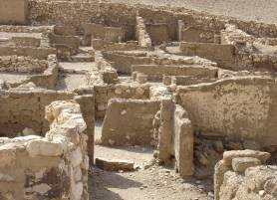
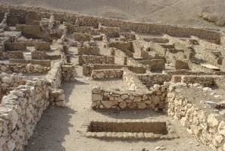
The foundations of the village houses are well preserved and run off both sides of a central street.

A great deal is known about life in the village as the artisans were literate and left documentation of village life on papyrus and slivers of limestone known as ostraca which they used as rudimentary notepads. From these, information has been gathered about where individuals lived, what their jobs were, what they ate and how novel was their sex life. The French author Christian Jacq brought the village to life in wonderful detail through his Ramses and Stone of Light series of books. These are available in translation throughout the world and give an insight into the intrigues of life in ancient Egypt.

The village, whose entrance lay at the opposite end of the village to the one which visitors enter now, is remote and waterless so food and water had to be brought there daily. These supplies were almost certainly brought to the gates and left there, as it is unlikely that deliverymen or carts would be allowed inside. On occasion, there were interruptions to the supplies, which caused great hardship, and workmen responded to these disruptions by stopping work and marching to nearby temples to demand payment. Such a demonstration took place in the Medinet Habu during the reign of Ramses III and villagers fled to that temple for protection when Libyans attacked them in the reign of Ramses IV.

The houses run off both sides of a central street and were built of mud brick on stone foundations. The external walls were plastered and then painted white. Each house fitted a basic four-room design, one of which was an unroofed cooking area. Some houses had storage cellars. All houses had a raised platform in one room, which could have been used as an altar or a birthing area but may have served both purposes. Many houses had stone lintels above the front doors on which the names of its occupants were carved and this habit made identification of various homes easier. It also shows that not everything was equal because the status and wealth of its owner dictated the elaborateness with which a house was finished. Today, the grey stone and the grey dust give the village the ethereal look found in old black and white photos.

While they were not working on tombs for the Pharaohs, artisans worked on tombs for themselves and for wealthy Theban dignitaries. Pyramids had long ago stopped being the Pharaohs’ main choice for tomb making but it was still popular with Thebans and there are several examples of small pyramid tombs here. One, which has been restored, sits above a sunken burial chamber of Sennedjem, the entrance to which lies not inside the pyramid but in front of it. In addition, to the workers' tombs, two sarcophagi of the Divine Adoratrices (Wives of Amun) were found at the Deir el Medina although it is doubtful that they were actually buried there and it is more likely that they were moved there from the Medinet Habu with the intent of recycling them during a breakdown in government control in the late 20th dynasty.
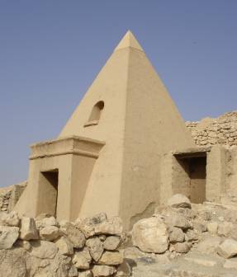
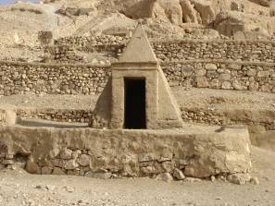
Pyramids tombs remained popular with Thebans long after they fell from favour elsewhere.
Left: Pyramid marking the tomb of Sennedjem
Above: Pyramid marking an unknown tomb.

The villagers were used to living with death and as they appear to have had little fear of it, tombs have been built right up to the walls of the houses - although few of them are open to the public. However, there is access to the splendid tombs of Sennedjem, Inherkhau, and Pashedu. These tombs have very steep entrances to single vaulted-roof burial chambers and although they are small, they are exquisitely decorated and have an atmosphere that many of the larger tombs lack. One ticket gains admission to the tombs of Sennedjem and Inherkhau but a further ticket has to be bought to visit the tomb of Pashedu. It is clear from the delicately painted walls and ceilings of these tombs that the artisans were truly masters of their craft.

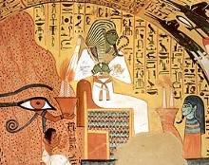
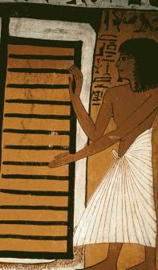
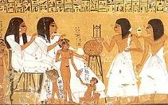
Upper left: Inherkhau and his wife receive offerings from members of their family.
Lower left: Osiris on this throne in front of the Theban hills - from the tomb of Pashedu
Right: Sennedjem waits at the door to the underworld.

The villagers seem to have been particularly devout, as there is an exceptionally high number of shrines for such a small village. Inside the high mud-brick outer walls of the temple to Hathor are the remains of shrines to various workmen so in addition to the national and local deities worshipped there, an element of ancestor worship is evident. Evidence of this has also been found inside some of the houses. In these cases, the reference seems to be to relatives who have recently died.

The actual temple to Hathor and Maat is little larger than the average European family house but it has both grace and style. Its front wall is covered in Greek graffiti, which due to its age makes in interesting rather than offensive. Immediately inside the single entrance is a small courtyard with columns showing images of Hathor and a short staircase leading to the roof, which has an excellent view of the surrounding countryside and the Ramusseum. At the rear of the courtyard, behind a low curtain wall, are three small chapels: the one on the far right is worth seeing as it has a series of god images and the colour is still very good.
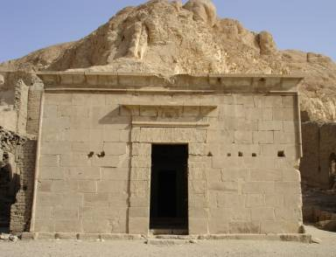
The temple of Hathor is exceptionally small but has grace and style

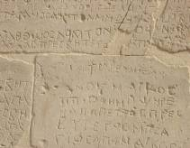
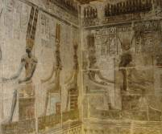
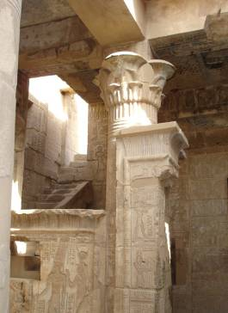

Above left: : Although built by the Greeks, the chapels honour Egyptian gods Bottom left: Greek graffiti adorns the front wall of the temple
Above right: Stairs lead from the courtyard to the temple roof.

Beyond this temple, the ruins of the monastery and several even more ancient temples rise towards the rock face that towers over them. Further on is a deep dry rock cleft that once served as the village reservoir.
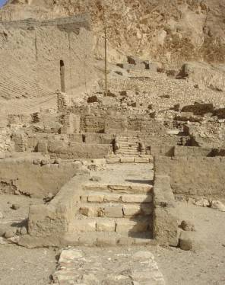
On the northern side of the Hathor Temple, the ruins of several other ancient temples rise up the hillside.
The abundance of temples, tombs and treasures in Thebes has meant that the study of Theban village life was for a long time very neglected. This village puts that right. In all the Deir el Medina is a very atmospheric place and it is easy to believe that the energies of its previous inhabitants still effects the village today. When you walk along its silent streets, it is easy to imagine the laughter of children and the chatter of women as they brought water from the well. The juxtaposition and close proximity of houses to graves also highlights how easily life and death co-exist when faith in eternity is absolute.

The village does not have as many visitors as some of the other sites on the West Bank but as the tombs are so small, it can mean quite a long wait if several tour buses have arrived before you. Tour groups tend only visit the tombs on this site and often ignore the temple, so if you visit the temple first and stay there until the tour groups have gone, you can once more enjoy the peace of this absorbing place and view the tombs at your leisure.
- - - - - - - - - - - - - - - - - - - - - - - - - - - - - - - -

Variations on the spelling of Inherkhau, = Inherkha, Ankherha
Variations on the spelling ostraca = ostraka

